**Value and volume: Why carbon credit policy must evolve with ambition**

Author: Emma Herd, Co-Lead, EY Net Zero Centre, EY Australia

*Removals-based carbon credits are an extremely valuable commodity in a low-carbon world. With the right policy settings, Australia could generate carbon credits at scale, lifting national income by around $50 billion by 2050. What stands in our way?*

Australia has a distinct advantage in a net zero economy: the ability to supply high-integrity credits that create both economic and environmental value.

EY Net Zero Centre analysis, published in the flagship report *Charting Australia's path to 2035 and beyond*, identifies scaling up land sector removals as one of the eight ‘keys’ to unlocking lower costs, improving security and providing net zero emissions.

Today, that potential remains under-realised. What can we do?

**Carbon credits are an economic asset**

EY Net Zero Centre analysis finds that cost-effective action to achieve net zero would reduce Australia’s gross emissions 75-80% by 2050. Residual emissions – largely from export activities – would need to be offset by high-integrity credits.

EY analysis finds that ‘homegrown’ land-sector carbon credits could contribute 27% of Australia’s abatement task by 2050, generate $44 billion in credit value and lift national income by $49 billion.

Agriculture illustrates the potential. By mid-century, agriculture could account for nearly half of Australia’s gross emissions, up from 18% today. Agriculture will likely need to rely on carbon credits to reach net zero. Given that 70% of Australia’s agricultural output is exported, it will be important that the value of those credits is passed on to international consumers, not subsidised by Australian taxpayers.

By creating cost-competitive credits domestically, Australia can reduce the need to purchase international units, avoiding capital outflows and reducing risk for integrity concerns.

If aligned with nature repair, land-sector credits could also help Australia build a nature-positive global reputation and support a 34% increase in habitat across priority regions, while increasing agricultural value added by 30% and lifting national income by an additional $45 billion.

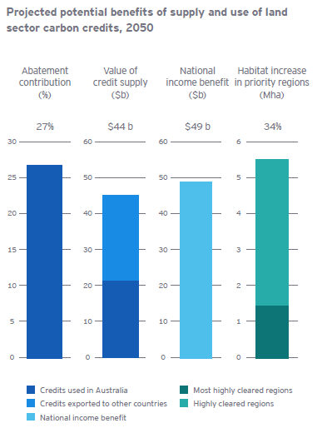

Source: EY Net Zero Centre, 2025.

**Realising potential requires policy reform**

These are big numbers. Now policy must evolve to unlock them.

Current policy settings for Australian Carbon Credit Units (ACCUs) provide a robust foundation and are attracting heavy industry and mining under the Safeguard Mechanism (SGM). However, challenges outlined in the EY Net Zero Centre report include:

* **Policy uncertainty and boom–bust dynamics**, which weaken incentives and discourage ACCU supply expansion
* **Barriers to credit use outside the SGM**, despite SGM facilities projected to account for only 50% of the Australian offsets required from 2030 to 2050
* **Limited alignment with nature repair goals**, meaning land-sector plantings provide carbon sequestration but miss opportunities to stack wider benefits
* **Stakeholder hesitation about large-scale land use change**, especially where the economic or social value is unclear

The risk? Australia will struggle to achieve net zero emissions without relying on imported carbon credits, missing out on billions in national income and risking undermining public confidence.

The way forward? An integrated approach, backed by policy reform that enables credit use across more sectors, enhances investor confidence through greater clarity and opportunities, explores the merits of managed exports, and evolves credit rules to include nature repair and regeneration.

Done right, Australia can grow both the value and volume of carbon credits, reinforcing integrity and delivering wider benefits, while positioning the nation as a global leader in high-quality carbon supply. There’s no time to waste.